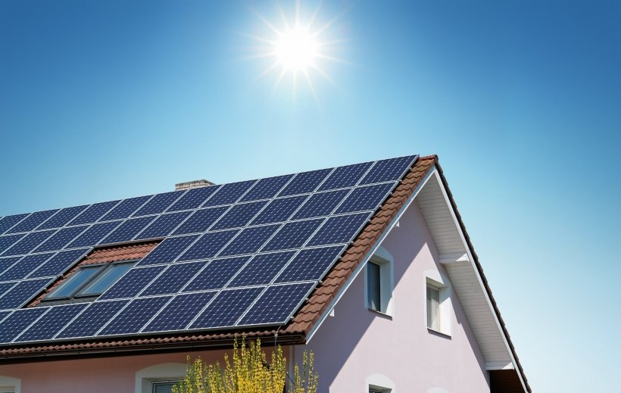

Data Science Project Plan

ZZSC9020 Data Science Project: Assessment 1A

**Group 13**

Caitlyn Ong (z5379456)

Aashray Sood (z3466748)

2 September 2024

University of New South Wales (UNSW),

Sydney, Australia.

# Introduction

XX

# Brief Literature Review

XX

# Methods, Software and Data Description

XX

XX

XX

XX

# Activities and Schedule

We adopted the waterfall project management approach due to the tight six-week timeline and well-defined project requirements established at the outset. The main activities in this project are broken down into five (5) key components:

1. Planning
2. Data Exploration
3. Data Analysis & Modelling
4. Report preparation
5. Presentation

The Gantt Chart in Appendix A illustrates the project timeline, task details, and key milestones, which are highlighted using relevant icons. Task lead times have been carefully considered incorporating recurring team meetings, online lecturer consultations, and deadline requirements.

As part of the planning phase, we established a social contract outlining our shared norms and values for collaborative working (see Appendix B). The social contract facilitates a collaborative environment where every team member can contribute, discuss, and agree on expected behaviours, tools, and working practices, ensuring clarity and alignment throughout the project.

The project team consists of Caitlyn Ong and Aashray Sood, who bring complementary expertise to the table. Caitlyn will lead the project, utilizing her business and consulting acumen to drive success and provide valuable industry insights, drawing on her prior experience in the energy sector. Aashray's Forensic Science background makes him an ideal fit for Research Lead, where he'll spearhead in-depth analysis and insights. Both team members will contribute equally to data exploration, analysis, and modelling, ensuring a collaborative approach and diverse perspectives throughout the project lifecycle.

# Appendix A

# Appendix B

